JMP instructions for adoptIQ analysis

JMP makes lots of things easy, once you have set up the model.

One thing it does not do is give you SS associated with individual contrasts, so I’m skipping all the ANOVA as contrasts material.

Load the adoptiveIQ.csv file. You should be able to load the .xlsx version of the data, but whenever I try (with JMP Pro 15), JMP tries to read the adoptive column, or both adoptive and biological columns as numbers. High and Low are not numbers so those become missing values (the dot). I do not know why and do not know how to fix this. Reading the .csv version is just fine.

Analyze / Fit model, put IQ into the Y box, make sure adoptive and biological are nominal (red bar) variables and put them both into the construct model effects box. Now we just have to add the interaction. Either select both variables in the select columns box or one variable in the model effects and one in the select columns box. Then click the Cross button. The second approach (one in each box) is convenient if you want to add many A\*something interactions (e.g. A\*B, A\*C, A\*D). Then you would click A in the model effects box and shift-select B, C, and D in the select columns box.

Your Model Specification box should look like:

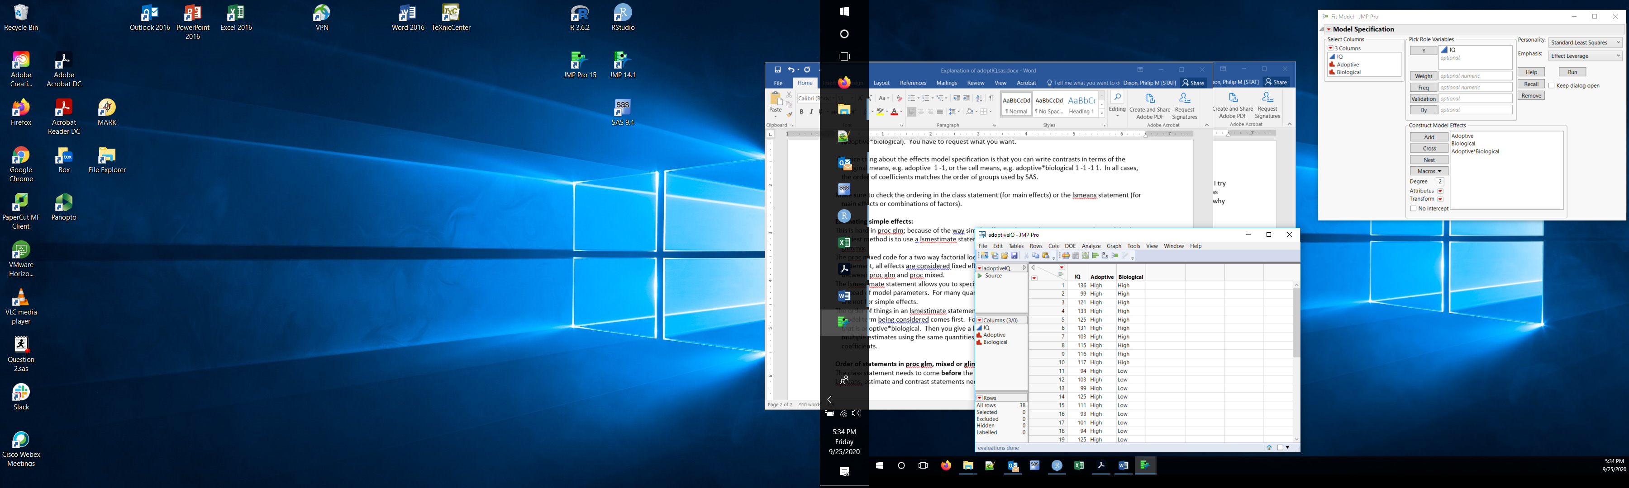

Click run, perhaps after checking the ‘Keep dialog open’ box.

The type III tests of each factor are in the Effects Tests box. This is closed by default (gray triangle pointing right). Click that triangle to expand the box and you get the type III tests.

If you really want sequential (type I tests), click the red triangle by Response IQ, select estimates and choose Sequential tests.

The default output includes marginal means for each effect (in the adoptive and biological columns, the Least Squares Means tables) and cell means (in the adoptive\*biological column). Additional information, e.g. contrasts or pairwise differences, are obtained under the red triangle by each variable. As before, you can get contrasts (LSMeans contrast) then using the mouse to click + or -, or all pairwise differences without multiple testing adjustment (LSMeans Student T) or with (LSMeans Tukey). The pairwise differences output includes confidence intervals for each difference.

Simple effects can be estimate by contrasts of the cell means (adoptive\*biological column).